INTRODUCION
Overview:
To invite people for freshers party in our college
Purpose:
To promote good thoughts our college

PROBLEM DEFINITION &DESIGN THINKING
Empathy map:
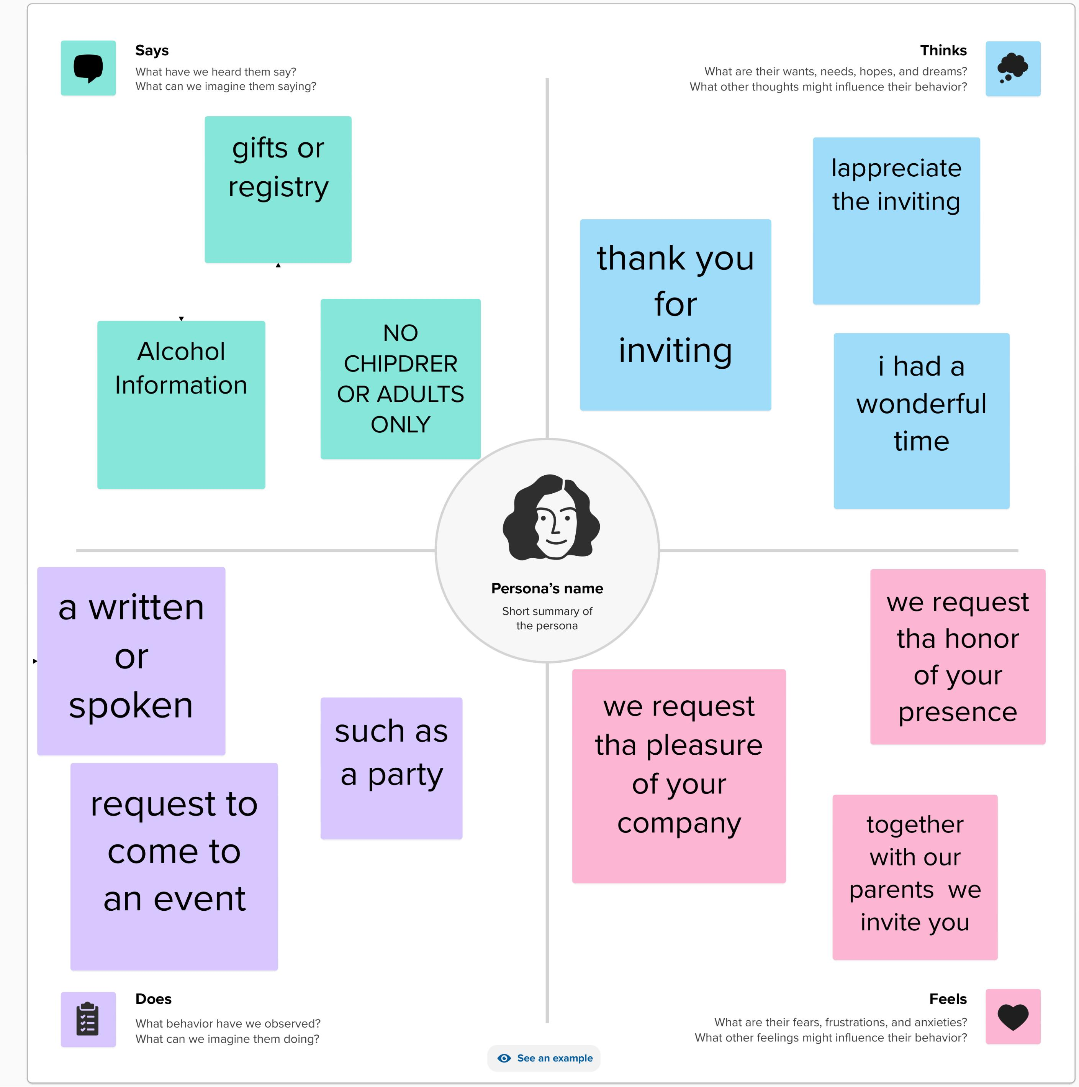

Brain storm:

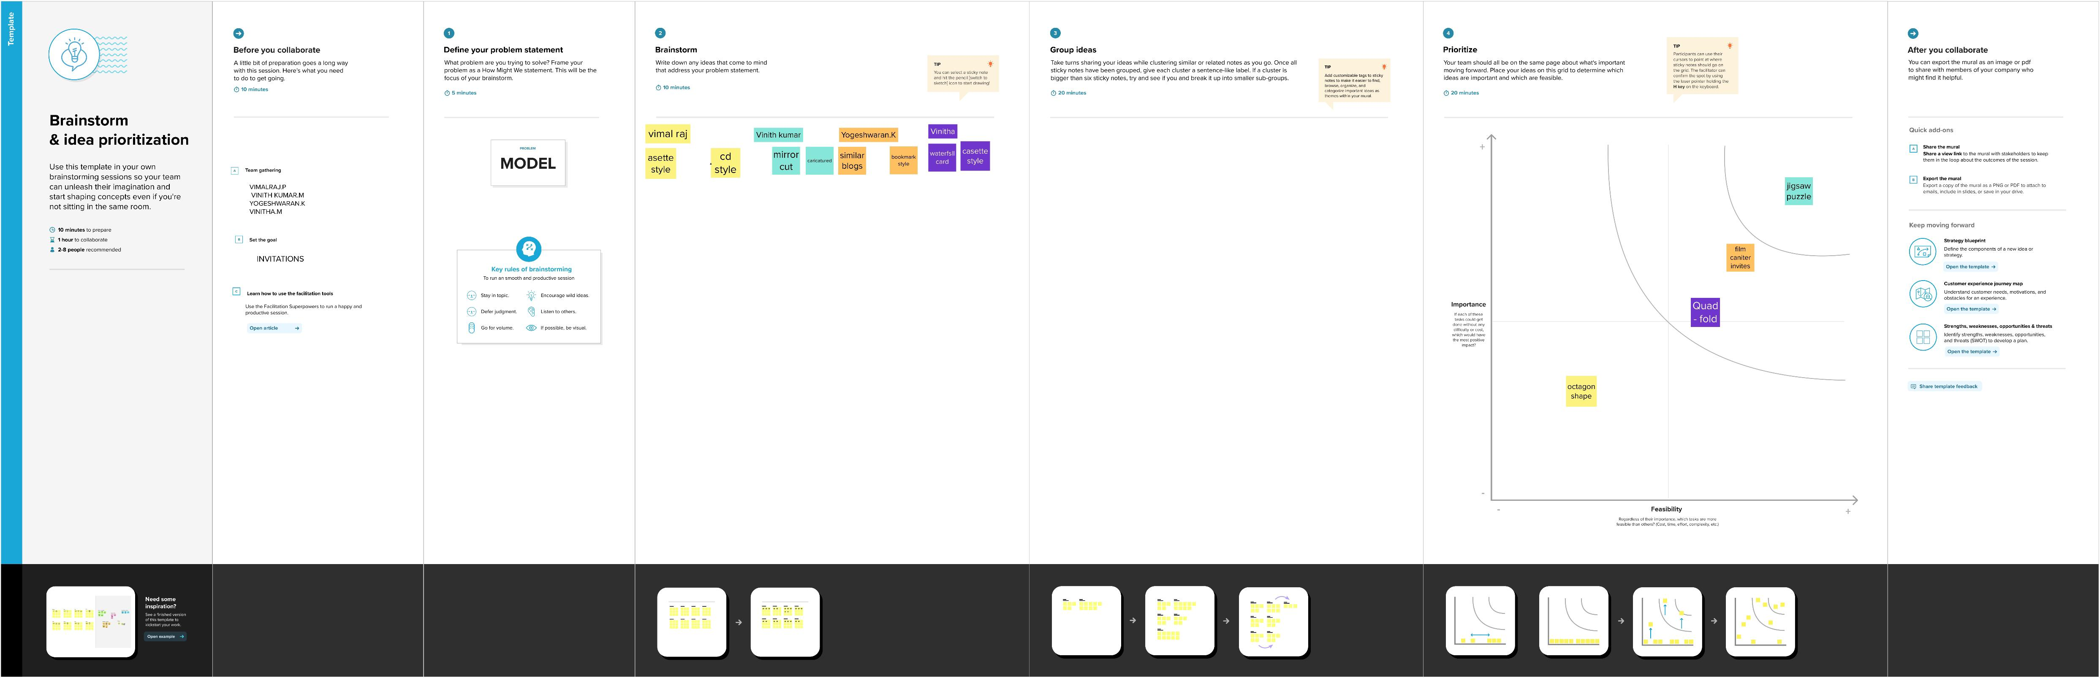

RESULT
Successfully great the invitation for the freshers party

- It reach as all student and parents esaily
- Some students may not attend the freshers party

APPLICATION:

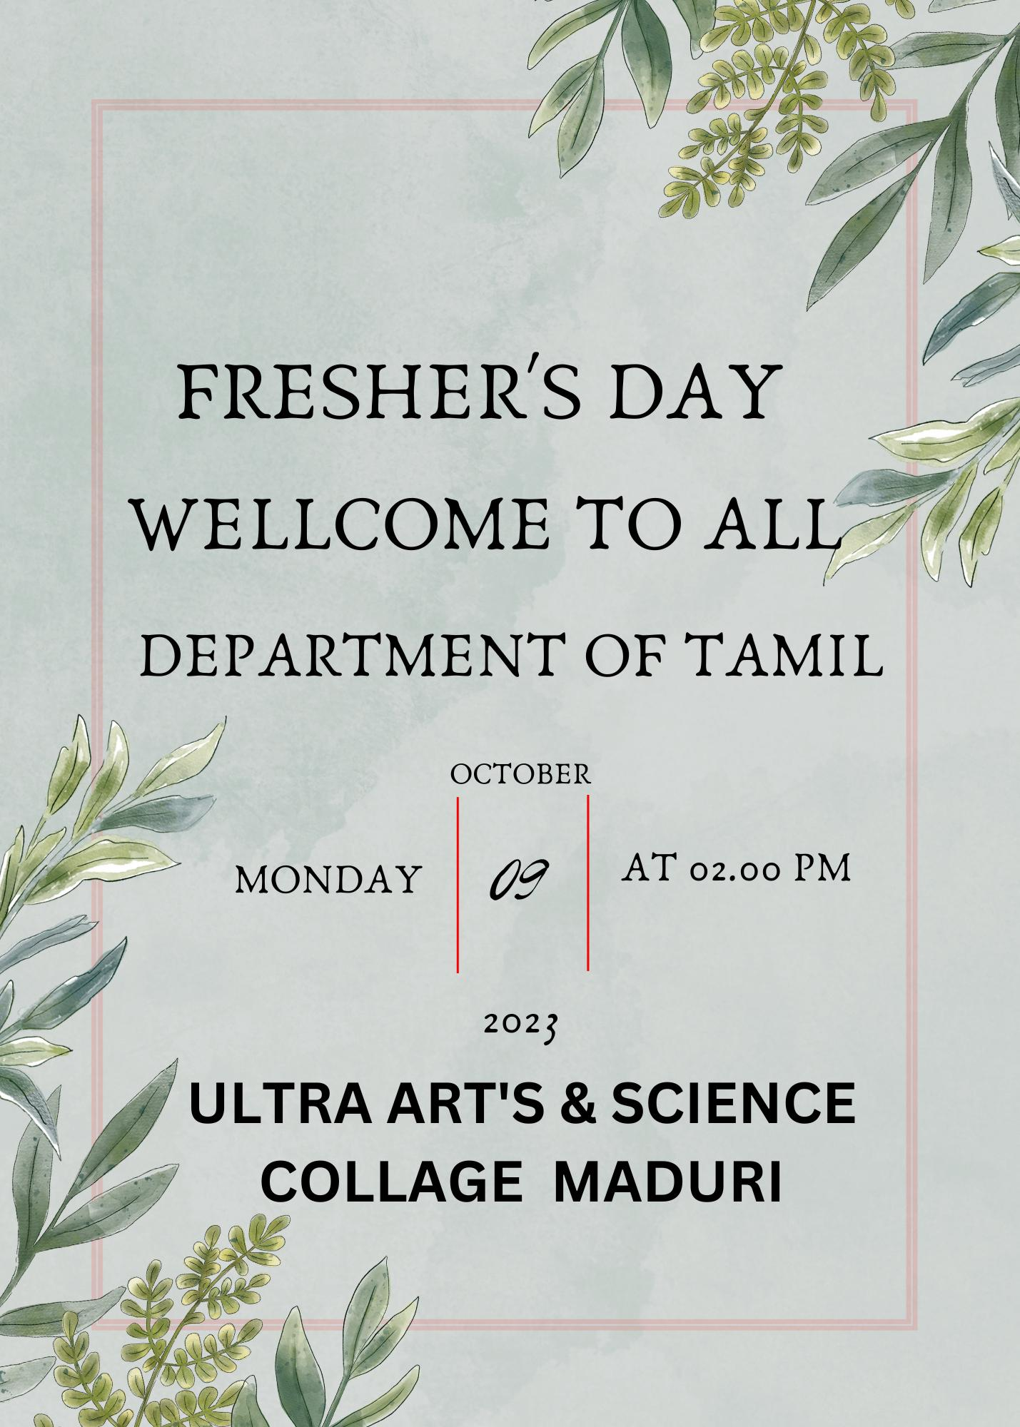

CONCLUSION:
With the help of canva app with esaily

